Sixth Form Reading

Warning - This list could seriously damage your health!

There is a wide range of books represented here – some can be read easily in a weekend and others contain some fairly substantial concepts which are not as easily digestible. There are undoubtedly some very good books which are not listed here.

Everyday Maths

For the most part relatively easy reads.

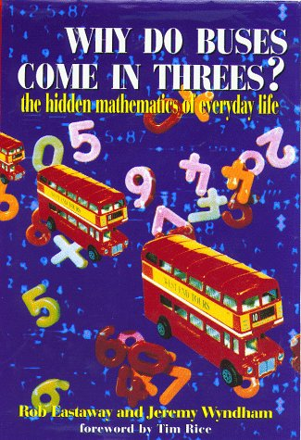 | **Why Do Buses Come in Threes?: The Hidden Mathematics of Everyday Life  Rob Eastaway, Jeremy Wyndham  1861052472 | Lots of questions about the curiosities of everyday life are answered in this delightfully irreverent and highly informative book. Why Do Buses Come in Threes? is a wonderful way to discover the relevance of math in absolutely everything we do, from dating and driving to gambling and cooking. Whether readers have a degree in astrophysics or haven't touched a math problem since school, this book will change the way they view the world.
 | **How Long Is a Piece of String?: More Hidden Mathematics of Everyday Life  Rob Eastaway, Jeremy Wyndham  1861056257 | And what is the link between a tin of baked beans and a men's urinal? This and many other questions are answered in this book. It is for anyone wanting to remind themselves - or discover for the first time - that maths is relevant to almost everything we do. Dating, travelling by car, gambling and ranking sportsmen all have links with intriguing mathematical problems that are explained in this book. It reveals the secrets behind some of the best con tricks and the hidden workings of the taxi meter, and explains how epidemics start and stop.
 | **How to Dunk a Doughnut: The Science of Everyday Life  Len Fisher  0753817055 | Science is all around us. In this book, Len Fisher provides scientific answers to familiar questions such as how to boil the perfect egg, how to catch a ball, the physics of sex, and why some vegetables absorb more gravy than others.
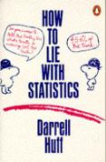 | How to Lie with Statistics  Darrell Huff  0140136290 | "A sort of primer in ways to use statistics to deceive", this book introduces the reader to the niceties of samples (random or stratified random), averages (mean, median or modal), errors (probable, standard or unintentional), graphs, indexes and other tools of democratic persuasion.
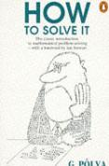 | How to Solve It: A New Aspect of Mathematical Method  G. Polya  0140124993 | A perennial bestseller by eminent mathematician G. Polya, How to Solve It will show anyone in any field how to think straight. In lucid and appealing prose, Polya reveals how the mathematical method of demonstrating a proof or finding an unknown can be of help in attacking any problem that can be "reasoned" out - from building a bridge to winning a game of anagrams. Generations of readers have relished Polya's deft - indeed, brilliant - instructions on stripping away irrelevancies and going straight to the heart of the problem. [JJA]
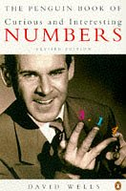 | **The Penguin Dictionary of Curious and Interesting Numbers  D.G. Wells  0140080295 | First published in 1986, this mind-boggling and entertaining dictionary, arranged in order of magnitude, exposes the fascinating facts about certain numbers and number sequences - very large primes, amicable numbers and golden squares to give but a few examples.
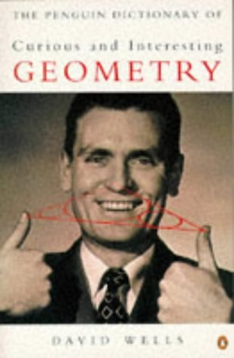 | **The Penguin Dictionary of Curious and Interesting Geometry  David Wells  0140118136 | A fascinating book that has something for anyone with an interest in geometry, whether they're still at school or just completing a PhD in mathematics. Mathematics is probably the closest human beings come to touching eternity, and geometrical discoveries made by the Babylonians or Greeks thousands of years ago are as valid and beautiful today as they were on the day they were made. You can find those discoveries here with work by modern geometricians, but Wells doesn't forget the special appeal geometry has for the eye and the aesthetic sense: there are also a lot of beautiful and sometimes mind-twisting diagrams.
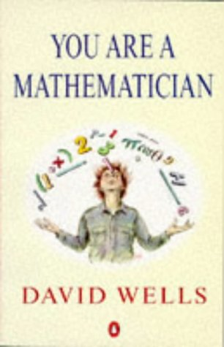 | You Are a Mathematician  David Wells  014017480X | A delightful foray into the world of mathematics that's easy on the brain, rich with intriguing historical facts and anecdotes, as well as profiles of famous mathematicians like Euclid and Lewis Carroll. In his always entertaining style, David Wells introduces such brain-tingling topics as the Konigsberg bridge problem, the Game of Life, Koch snowflakes, and Rabbi Moses' box. From the earliest mathematics of the ancient Egyptians and Greeks to the latest popular online mathematical games, You Are a Mathematician takes readers on a sometimes bizarre, but wildly entertaining journey.

Biography

And you thought mathematicians were boring – wait till you’ve read some of these!

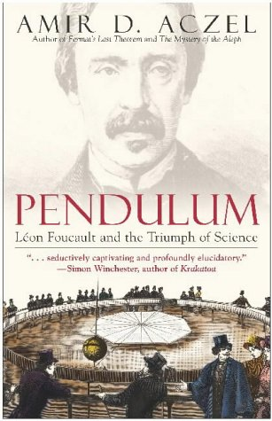 | Pendulum: Leon Foucault and the Triumph of Science  Amir D. Aczel  0743464796 | The dramatic story of French physicist Leon Foucault, the scientific genius whose famous pendulum would change the way we see our world forever.
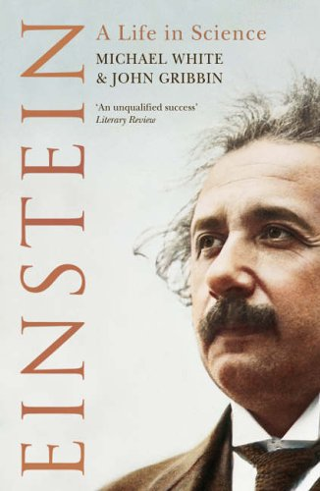 | Einstein: A Life in Science  John Gribbin, Michael White  0743263898 | As much as we all know that 'E = mc²' was Einstein's most important and groundbreaking equation, do we really know what it means or why Einstein is regarded as one of history's foremost thinkers? In this absorbing biography Michael White and John Gribbin reveal the man behind the physics and introduce us to his theories in an accessible and fascinating way. EINSTEIN explains how the scientific icon changed our view of the world and why no one can ever hope to understand that world without first understanding his work.
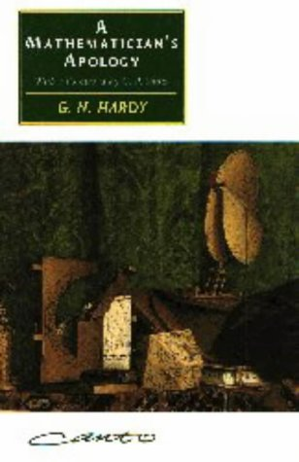 | A Mathematician's Apology  G.H. Hardy,  C.P. Snow (Foreword)  0521427061 | G. H. Hardy was one of this century's finest mathematical thinkers, renowned among his contemporaries as a 'real mathematician ...the purest of the pure'. He was also, as C. P. Snow recounts 'unorthodox, eccentric, radical, ready to talk about anything'. This 'apology', written in 1940 as his mathematical powers were declining, offers a brilliant and engaging account of mathematics as very much more than a science; C. P. Snow's Foreword gives sympathetic and witty insights into Hardy's life, with its rich store of anecdotes concerning his aphorisms and idiosyncrasies, and his passion for cricket. This is a unique account of the fascination of mathematics and of one of its most compelling exponents in modern times.
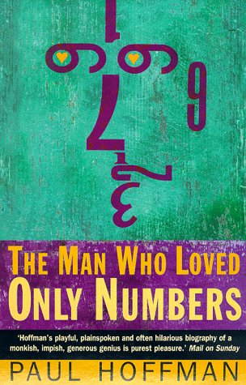 | The Man Who Loved Only Numbers: Story of Paul Erdos and the Search for Mathematical Truth  Paul Hoffman  1857028295 | Paul Erdos, the most prolific and eccentric mathematician of our times, forsook all creature comforts to pursue his lifelong study of numbers. He was a man who possessed unimaginable powers of thought, yet was unable to manage some of the simplest daily tasks. For more than six decades Erdos lived out of two tattered suitcases, criss-crossing four continents at a frenzied pace, chasing mathematical problems. Erdos saw mathematics as a search for lasting beauty and ultimate truth. It was a search he never abandoned, even as his life was torn revolution in his native Hungary, the rise of Nazism and the Cold War. This is an intimate look at the world of mathematics and an unforgettable portrait of Erdos, a charming and impish philosopher scientist whose accomplishments continue to enrich and inform our world. [HEA]
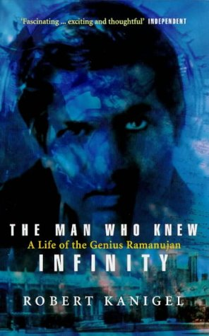 | The Man Who Knew Infinity: Life of the Genius Ramanuja  Robert Kanigel  0349104522 | The tale of a relationship between a young Indian mathematics genius, Ramanujan, and his tutor at Cambridge University, G.H. Hardy. The reader is taken on a journey through numbers theory in a language of symbols which the author has tried to make clear to the general reader.

Applied Maths

Some fairly meaty concepts here, but certainly not to be shied away from.

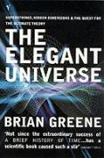 | **The Elegant Universe: Superstrings, Hidden Dimensions and the Quest for the Ultimate Theory  Brian Greene  009928992X | To write a book to explain in simple, non-mathematical terms, superstring theory is not a simple task - Greene does a very good job. Superstrings are a theory of particle physics that lays claim to being the ultimate "Theory of Everything", merging Einstein's relativity and quantum mechanics into an understanding of the physics of the very small and very large in the Universe. Superstring theory is still very much in its infancy and The Elegant Universe does not claim that all the problems have been solved, in fact a point is made of pointing out all the present deficiencies of the theory. Not a book for the very beginner but anyone who has read popular accounts of particle physics and relativity should gain a lot from reading this book. Not an easy read, not for style reasons but simply for the difficulty of some of the concepts involved. Superstring theory may or may not be the theory of everything but this book will certainly tell you what we think we know so far. Definitely recommended but don't expect to read it in a weekend.
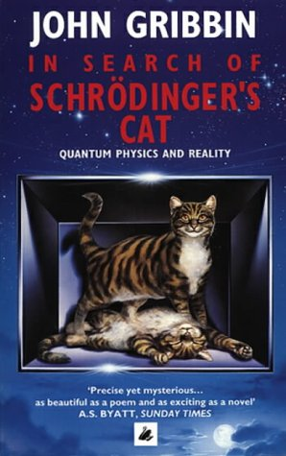 | In Search of Schrodinger's Cat  John Gribbin  0552125555 | Quantum theory is so shocking that Einstein could not bring himself to accept it. It provides the fundamental underpinning of all modern sciences. This book tells the complete story of quantum mechanics, a truth stranger than any fiction. Gribbin takes us step by step into an ever more bizarre and fascinating place, requiring only that we approach it with an open mind. He introduces the scientists who developed quantum theory. And in a world full of its own delights, mysteries and surprises, he searches for Schrödinger's Cat - a search for quantum reality. In Search of Schrödinger's Cat is a fascinating and delightful introduction to the strange world of the quantum - an essential element in understanding today's world. [DON]
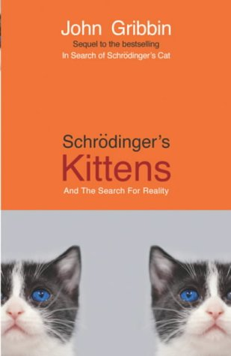 | **Schrodinger's Kittens and the Search for Reality: The Quantum Mysteries Solved  John Gribbin  1857994027 | Following on from his bestseller, Schrodinger’s Cat, Gribbin presents the recent dramatic improvements in experimental techniques that have enabled physicists to formulate and test new theories about the nature of light. He describes these theories not in terms of hard-to-imagine entities like spinning subnuclear particles, but in terms of the fate of two small cats, separated at a tender age and carried to opposite ends of the universe. In this way Gribbin introduces the reader to such new developments as quantum cryptography, through which unbreakable codes can be made, and goes on to possible future developments such as the idea that the 'entanglement' of quantum particles could be a way to build a Star Trek style teleportation machine. [DON]
 | **"New Scientist" Guide to Chaos  Nina Hall  0140145710 | A collection of articles, currently running in the "New Scientist", on the theory and application of chaos from economics to animal behaviour. The articles featured include those by Ian Stewart, author of "Does God Play Dice?", Franco Vivaldi and Benoit Mandelbrot.
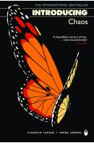 | **Introducing Chaos  Ziauddin Sardar, Iwona Abrams (Illustrator)  1840460784 | Providing an introduction to the controversial field of chaos theory, this text shows how chaos makes its presence felt in many varieties of event, from the fluctuation of animal populations to the ups and downs of the stock market. It also exmaines the roots of chaos in modern mathematics and physics, and explores the relationships between chaos and complexity, the unifying theory which suggests that all complex systems evolve from a few simple rules.
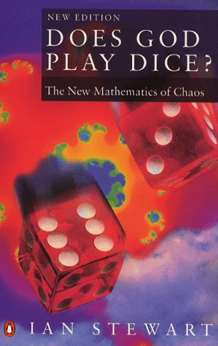 | **Does God Play Dice?: Mathematics of Chaos  Ian Stewart  0140125019 | This text explains how mathematics attempts to cope with chaotic behaviour in many different circumstances, for example, from gas dynamics to the stock exchange, through quantum mechanics and much else besides.  [CNG – a one chapter at a time book, if you want it all to sink in]

Major Mathematical Problems

No more coconuts – these are mathematical breakthroughs already made and a hint at those yet to come…..

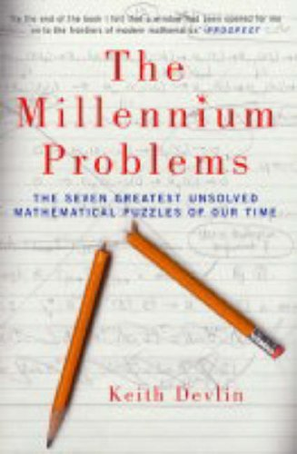 | The Millennium Problems: The Seven Greatest Unsolved Mathematical Puzzles of Our Time  Keith Devlin  1862077355 | In 2000, the Clay Foundation announced a historic competition: whoever could solve any of seven extraordinarily difficult mathematical problems, and have the solution acknowledged as correct by the experts, would receive $1million in prize money. They encompass many of the most fascinating areas of pure and applied mathematics, from topology and number theory to particle physics, cryptography, computing and even aircraft design. Devlin describes here what the seven problems are, how they came about, and what they mean for mathematics and science. In the hands of Devlin, each Millennium Problem becomes a fascinating window onto the deepest questions in the field.
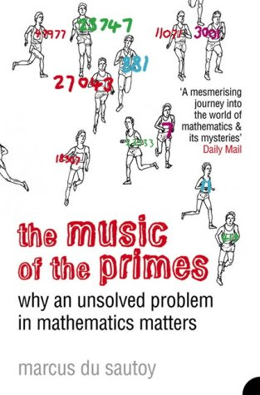 | The Music of the Primes: Why an Unsolved Problem in Mathematics Matters  Marcus du Sautoy  1841155802 | Apparently simple questions about prime numbers have confounded mathematicians ever since the Ancient Greeks. In 1859, the German mathematician Bernard Riemann proposed an idea which seemed to reveal a magical harmony in the numerical landscape. Yet Riemann never publicly provided a proof for his hypothesis and his housekeeper burnt all his personal papers on his death. Whoever cracks Riemann's hypothesis will go down in history, for it has implications far beyond mathematics – business (security and e-commerce), science (Quantum Mechanics and Chaos Theory) and the future of computing. Yet, it remains unsolved. du Sautoy here tells the story of the eccentric and brilliant men who have struggled to solve one of the biggest mysteries in science. It is a story of strange journeys, last-minute escapes from death and the unquenchable thirst for knowledge. Above all, it is a moving and awe-inspiring evocation of the mathematician's world and the beauties and mysteries it contains.
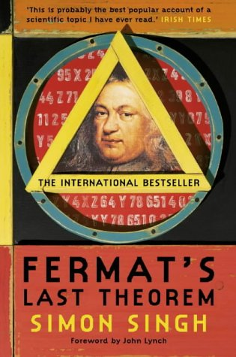 | **Fermat's Last Theorem  Simon Singh  1841157910 | The story of a puzzle that every child can understand but has baffled mathematicians for 300 years. Aged ten, Andrew Wiles stumbled across the puzzle, leading to a lifelong obsession with solving the world's greatest mathematical problem. A story of human endeavour and intellectual brilliance, for all readers. First published in 1997.
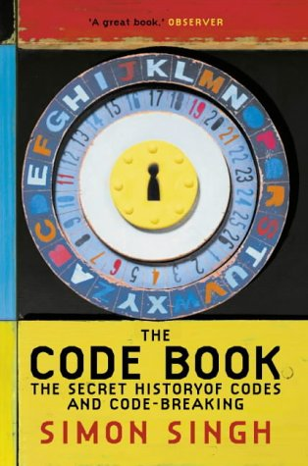 | The Code Book: The Secret History of Codes and Code-breaking  Simon Singh  1857028899 | The Code Book contains many fascinating accounts of code-breaking in action, from its use in unmasking the Man in the Iron Mask and the defeat of the Nazis to the breaking of a modern cipher system by a world-wide army of amateurs in 1994. It is especially good on the most recent developments, such as quantum cryptology and the thorny civil liberties issues raised by the advent of very secure cipher systems over the Internet. But Singh's mathematical prowess sometimes gets the better of his journalistic instincts, leading to technical descriptions that unnecessarily disrupt the narrative flow.
 | The Honors Class: Hilbert's Problems and Their Solvers  Benjamin H. Yandell  1568812167 | Presenting vivid portraits of the people who devoted their lives to meet Hilbert's challenge, this book shows us that mathematicians are as diverse as the rest of us despite their single-minded pursuit.

Science

A little bit of nearly everything…..

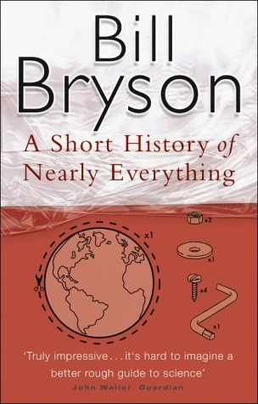 | A Short History of Nearly Everything  Bill Bryson  0552997048 | Bryson's presentation of the potentially incomprehensible subjects is full of clarity and enthusiasm. For example, he presents statistics not as mere numbers but explains just how astronomical and incomprehensive their scales are to our ordinary human mind. What is also nice about this book is that he describes the personalities, obsessions and eccentricities of those who made important scientific contributions. The political drama of scientific discovery and recognition is thrillingly narrated, and Bryson should be congratulated for his sympathetic recognition of those who made the first discoveries but were ignored by the world simply because their ideas were too radical for the age, only to be `discovered' by someone else later. [DON]
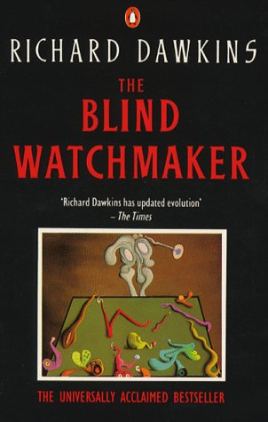 | **The Blind Watchmaker  Richard Dawkins  0140144811 | Edward Larson's research shows that most scientists today are not formally religious, but Dawkins is an in-your-face atheist: I want to persuade the reader, not just that the Darwinian world-view happens to be true, but that it is the only known theory that could, in principle, solve the mystery of our existence. The title refers to the Rev. William Paley's 1802 work, Natural Theology, which argued that just as finding a watch would lead you to conclude that a watchmaker must exist, the complexity of living organisms proves that a Creator exists. Not so, says Dawkins: "All appearances to the contrary, the only watchmaker in nature is the blind forces of physics, albeit deployed in a very special way...it is the blind watchmaker". Dawkins is a hard-core scientist: he doesn't just tell you what is so, he shows you how to find out for yourself.
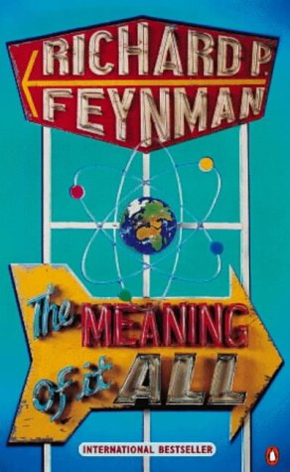 | The Meaning of It All  Richard Feynman  0140276351 | This text presents three recently discovered public lectures from the 60s in which Feynman addresses a non-scientific audience. Feynman attempts to engage an audience with the questions that most inspired and troubled him. Beginning by asking what is the value of science, Feynman goes on to address various related questions: can scientific views be reconciled with religious beliefs? Why in this supposedly scientific age is there such widespread fascination with flying saucers, astrology and martian invasions? How does the media betray the public? What is the value of doubt?
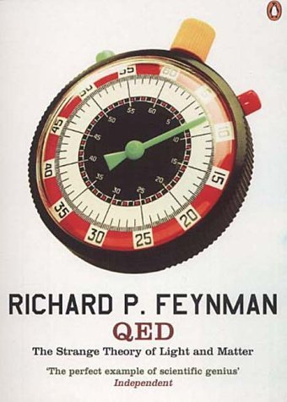 | **Q. E. D.: The Strange Theory of Light and Matter  Richard P. Feynman  0140125051 | Quantum electrodynamics - or QED, for short - is the revolutionary theory that explains how light and electrons interact. Thanks to richard Feynman and his colleagues, who won the Nobel Prize for their ground-breaking work in this area, it is also one of the rare parts of physics that is known for sure, a theory that has stood the text of time. Based on a series of lectures delivered to the general public at the University of California, Feynman here wittily explains the theory of quantum electrodynamics, the central aspect of much of modern physics.  This is not a particularly easy read because of the concepts involved, but is ultimately rewarding all the same.
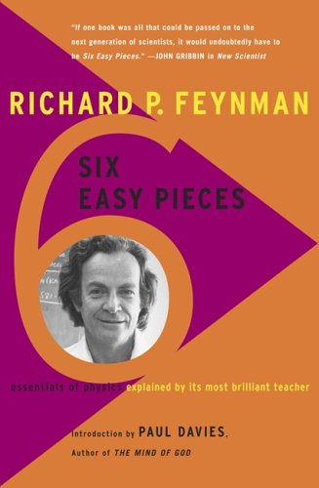 | **Lectures on Physics: Six Easy Pieces  Richard P. Feynman  0201408252 | Designed for non-scientists Six Easy Pieces is an unparalleled introduction to the world of physics. Six Easy Pieces, taken from the famous Lectures on Physics, represents the most accessible material from this series. In these six chapters, Feynman introduces the general reader to the following topics: atoms, basic physics, the relationship of physics to other topics, energy, gravitation, and quantum force. With his dazzling and inimitable wit, Feynman presents each discussion without equations or technical jargon. Filled with wonderful examples and clever illustrations, Six Easy Pieces is the ideal introduction to the fundamentals of physics by one of the most admired and accessible scientists of our time.
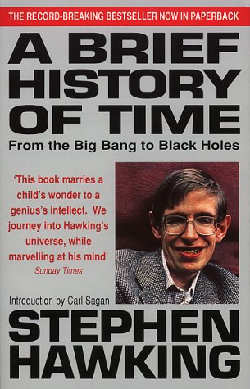 | A Brief History of Time: From the Big Bang to Black Holes  Stephen Hawking  0553175211 | Stephen Hawking, one of the most brilliant theoretical physicists in history, wrote this modern classic to help non-scientists understand fundamental questions of physics and our existence using a minimum of technical jargon. Among the topics gracefully covered are black holes, the Big Bang, the nature of time and physicists' search for a grand unifying theory. This is deep science; the concepts are so vast (or so tiny) that they cause mental vertigo while reading; one can't help but marvel at Hawking's ability to synthesize this difficult subject for people not used to thinking about such things. The journey is certainly worth taking for as Hawking says, the reward of understanding the universe may be a glimpse of "the mind of God".
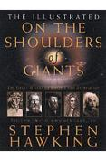 | On the Shoulders of Giants: The Great Works of Physics and Astronomy  Stephen Hawking  0762418982 | Stephen Hawking brings together the greatest works by Copernicus, Galileo, Kepler, Newton and Einstein showing how their pioneering discoveries changed the way we see the world. Hawking also provides glimpses into their lives and times - Galileo's trial in the Papal inquisition, Newton's bitter feuds with rivals and Einstein absent-mindedly jotting notes that would lead to his Theory of Relativity while pushing his baby son's pram. Hawking explains how the works of these men transformed the course of science - and gave us a better understanding of the universe and our place in it.
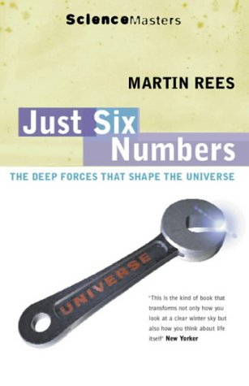 | Just Six Numbers: The Deep Forces That Shape the Universe  Martin J. Rees  0753810220 | Just six numbers govern the shape, size and texture of our universe. If their values were only fractionally different, we would not exist; nor, in many cases, would matter have had a chance to form. If the numbers that govern our universe were elegant-1, Pi or the Golden Mean - we would simply shrug and say that the universe was an elegant mathematical puzzle. But the numbers Martin Rees discusses are far from tidy. Was the universe "tweaked" or is it one of many universes, all run by slightly different but equally messy, rules?  Rees demonstrates how the cosmos is full of "fossils" from which we can deduce how our universe developed, as surely as we infer the Earth's past from the relics found in sedimentary rocks. Rees's theme is nothing less than the colossal richness of the universe. It is an ambitious book, if anything, it deserves to be longer.

History

The long ago, and the not so long ago – great for linking people with ideas and putting everything in context.

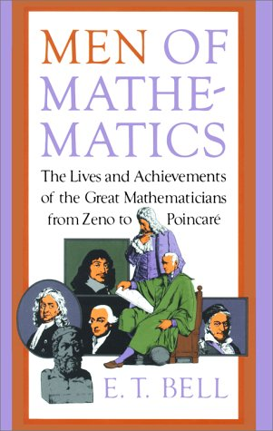 | Men of Mathematics  E. Bell  0671628186 | The achievements and lives of important world mathematicians prior to 1900. [DON]
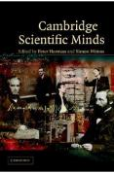 | Cambridge Scientific Minds  Peter Harman (Editor), Simon Mitton (Editor)  0521786126 | This is a unique account of some of Cambridge University's most eminent thinkers over the last 400 years, including Newton, Darwin, and Maxwell. The rapid establishment during the Newtonian era of a series of professorships for mathematics, chemistry, geometry and other sciences marked the University's scientific coming of age, but this volume's chronological balance reflects on the increasing importance of science in recent history also. Paul Dirac, Alan Turing and Stephen Hawking, among others, represent the recent intellectual efflorescence at Cambridge. Personal memoirs and historical essays, written by leading historians, scientists, and Nobel Laureates, make this as enjoyable to read as it is accessible.
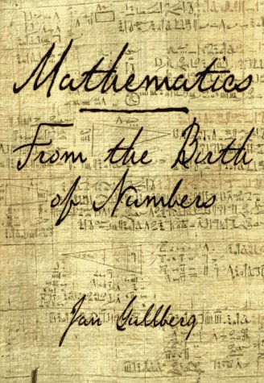 | Mathematics: From the Birth of Numbers  Jan Gullberg  039304002X | This wide-ranging survey looks at the history of mathematics from the invention of numbers and language, through the realms of arithmetic, algebra, geometry, trigonometry and calculus, to mathematical logic, set theory, topology, fractals and probability, and onwards to differential equations. The book is intended for the general reader, and links mathematics to the humanities, linguistics, the natural sciences and technology. [CNG – not a bedtime reading book, but great as a reference book for the history of ideas and for easy explanations of just about everything from year 7 to 1st/2nd year university level]

Miscellaneous

Well, just that really – all the others that are absolutely fantastic, but wouldn’t quite fit into any other category [arguably].

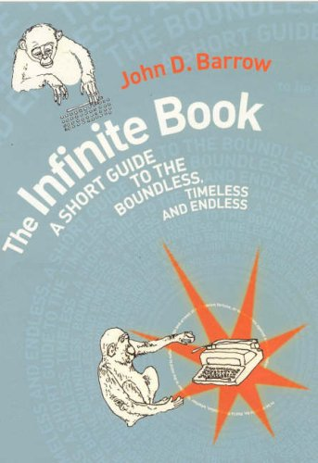 | The Infinite Book  John D. Barrow  0224069179 | Infinity is surely the strangest idea that humans have ever thought. Infinity is the place where things happen that don't. All manner of strange paradoxes and fantasies characterise an infinite universe. If our Universe is infinite then an infinite number of exact copies of you are at this very moment reading an identical sentence on an identical planet somewhere else in the Universe. What is it like to live in a Universe where nothing is original, where you can live forever, where anything that can be done, is done, over and over again? These are some of the questions that the idea of the infinite pushes us to ask. Many have lost their lives, their careers, or their freedom for talking about the idea of infinity. Barrow takes you on a tour of these dangerous questions and the strange answers that scientists, mathematicians, philosophers and theologians have come up with to deal with its threats to our sanity.
 | Alice in Numberland  John Baylis, Rod Haggarty  00333442423 | Fantastic reading for a foundation course introducing university mathematics. Recommended in the Oxford University introduction to the mathematics course study guide.
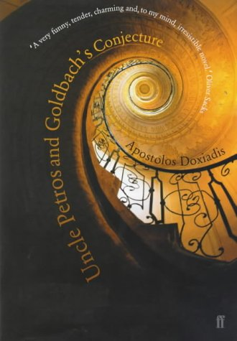 | Uncle Petros and Goldbach's Conjecture  Apostolos Doxiadis  0571205119 | This novel involves mathematics, and specifically Goldbach's Conjecture: that every prime number can be represented as two odd numbers added together - a theory that has yet to be conclusively proven or disproved. Even if this sort of thing usually bores you, it's worth trying this book, because the underlying themes are not so much mathematics as how one spends one's life, what constitutes success or failure, and whether knowledge is worth pursuing for its own sake or just a means to an end. The young Greek narrator is intrigued by his reclusive, despised Uncle Petros. After much prying he discovers that Petros, once a very promising mathematician, has devoted his life to the seemingly impossible task of proving Goldbach's Conjecture, to the exclusion of almost everything and everyone else. Through flashbacks we see how Petros became so fixated, and we follow his nephew's deliberation about whether to pursue mathematics like his uncle. Dioxiadis writes simply and elegantly, and leaves it to the reader to decide whether Petros is a hero or a fool. A splendid book. [HEA]
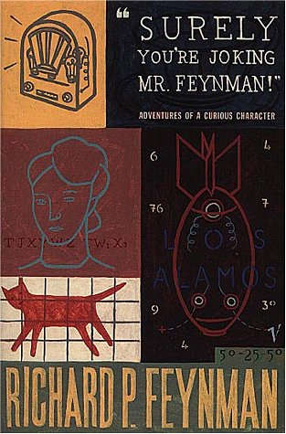 | **Surely You're Joking, Mr.Feynman!: Adventures of a Curious Character  Richard P. Feynman, Ralph Leighton  009917331X | Winner of the Nobel Prize for Physics in 1965, Richard Feynman was also a man who fell, often jumped, into adventure - as artist, safe-cracker, practical joker and storyteller. He explained physics to the likes of Einstein and Von Neumann, accompanied ballet on the bongo drums, and was judged mentally deficient by a US Army psychiatrist. Over a period of years, Feynman's conversations with his friend Ralph Leighton were first taped and then set down as they appear in this book, little changed from their spoken form, to give a self-portrait of a remarkable man.
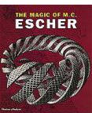 | The Magic of M.C.Escher  J.L. Locher, W.F. Veldhuysen  0500975914 | For the artist Escher, the skin of the visible world was a piece of cloth that could be cut, folded, shaped, and rearranged in many ways. This title presents many of Esher's greatest works, from the great master prints to numerous previously unpublished drawings, and arranges them to form a cinematic journey of discovery. His preparatory sketches and jottings, which give insights into the working processes of his mind are also included.
 | **Game, Set and Math: Enigmas and Conundrums  Ian Stewart  0140132376 | This book gives the reader a chance to experience a wide variety of quite advanced mathematics, and interact with these topics through puzzles set for the reader. These topics are presented in a very reader friendly way, interwining the mathematics into quite humorous and entertaining stories. The book hides very interesting mathematics behind these stories, which also prompt the reader to think further. An excellent, well-crafted book.
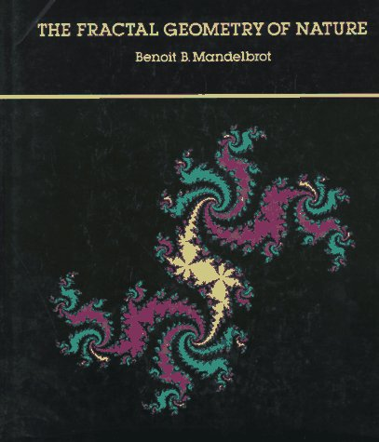 | The Fractal Geometry of Nature  Benoit B. Mandelbrot  0716711869 | Beauty and mathematics are often perceived as distant concepts by most people. The mathematically gifted would always refute such idea by stating that it is precisely elegance what guides many mathematical endeavors. Mandelbrot made it possible for fractal images to jump from obscure labs to the general knowledge. Many people since regard mathematics somehow with a different perspective. Although the book requires some basic knowledge of math it is not difficult to follow.

